Assignment No.15
Problem Statement:
Create a serverless computing service.
Solution:
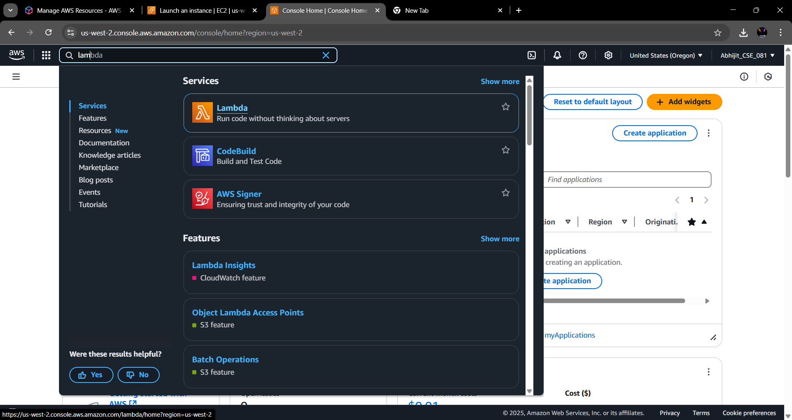
Step 1: Search for Lambda and click on it.

Step 2: Click on Create a function button.
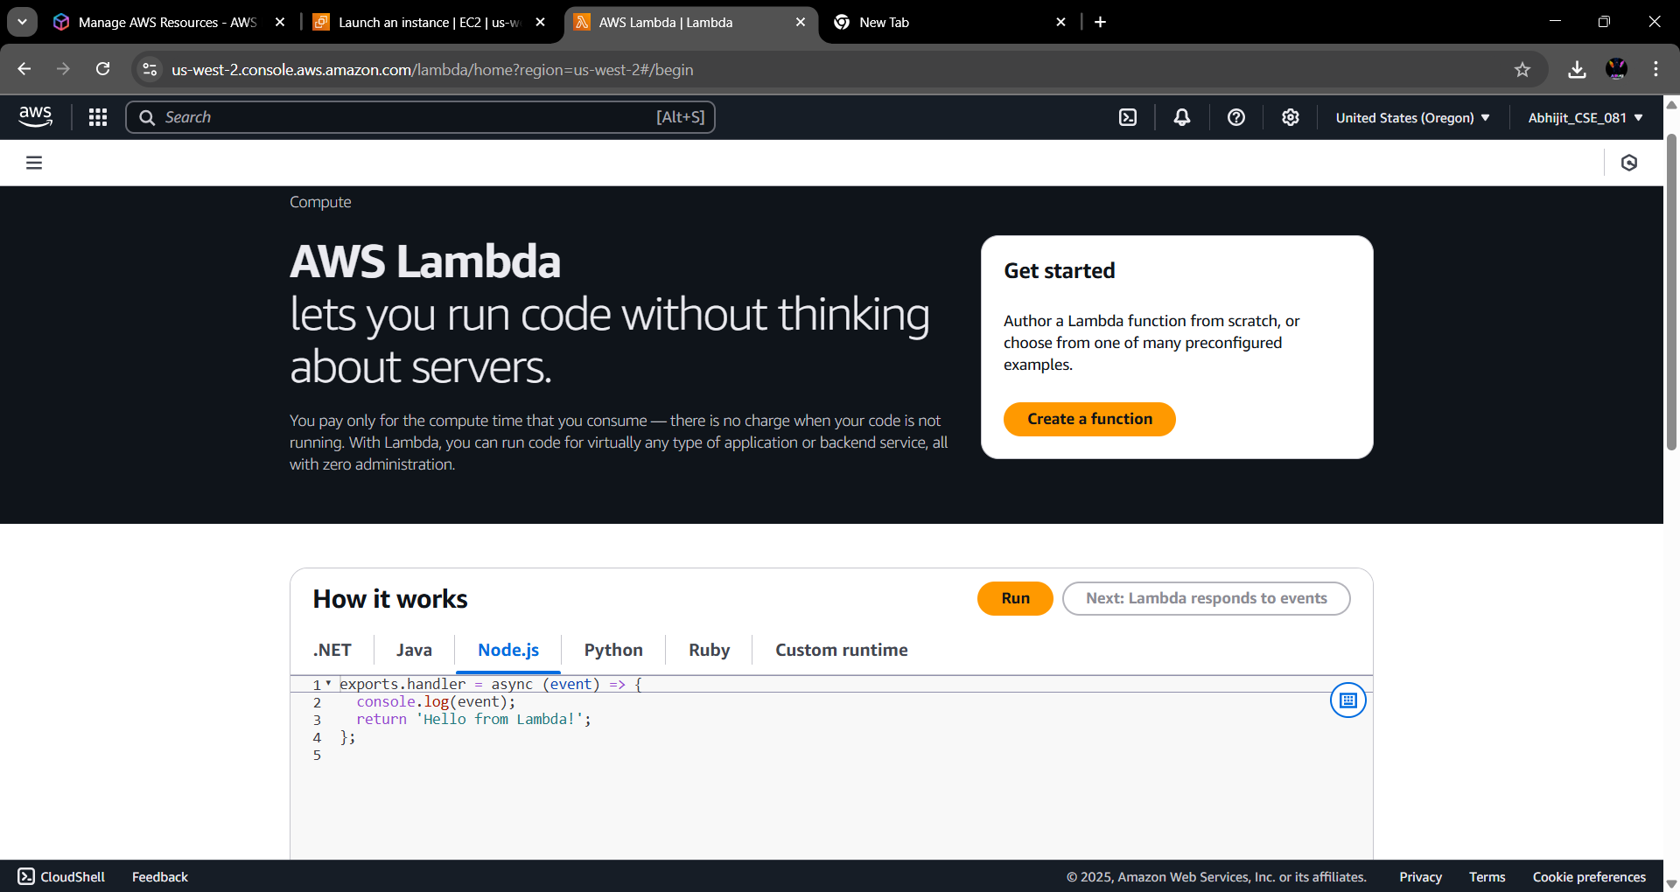

Step 3: Give a name to the function and under runtime select Node.js.22. x.
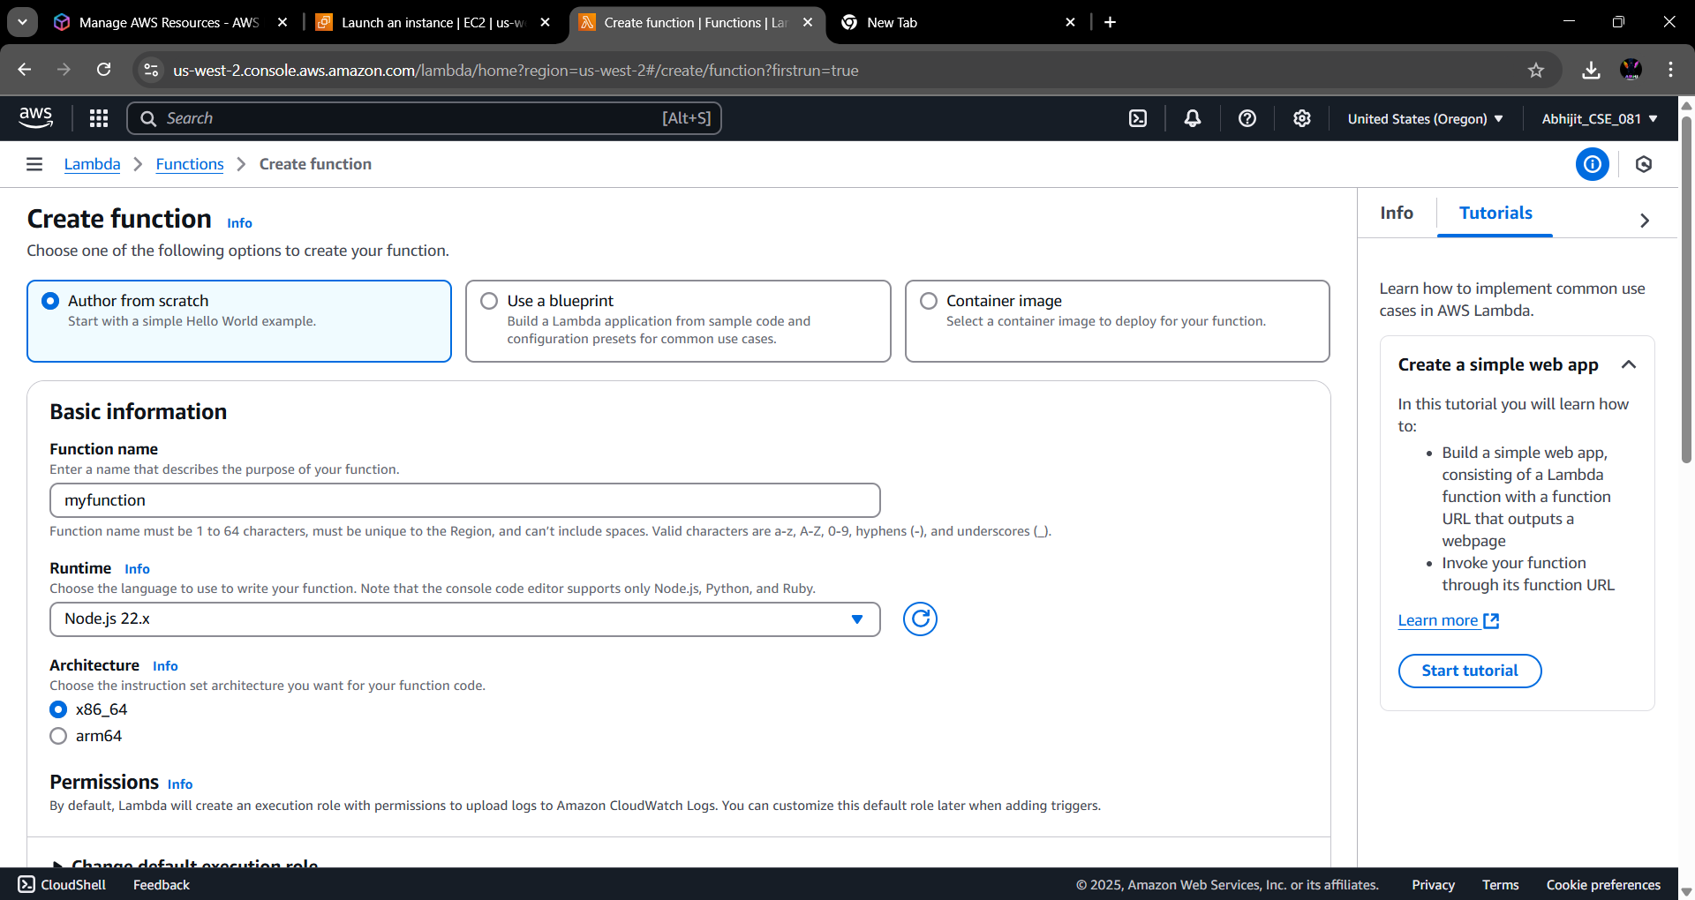

Step 4: Under the Advanced settings, check the Enable Function URL checkbox & under Auth type, select NONE. Then click on Create Function.
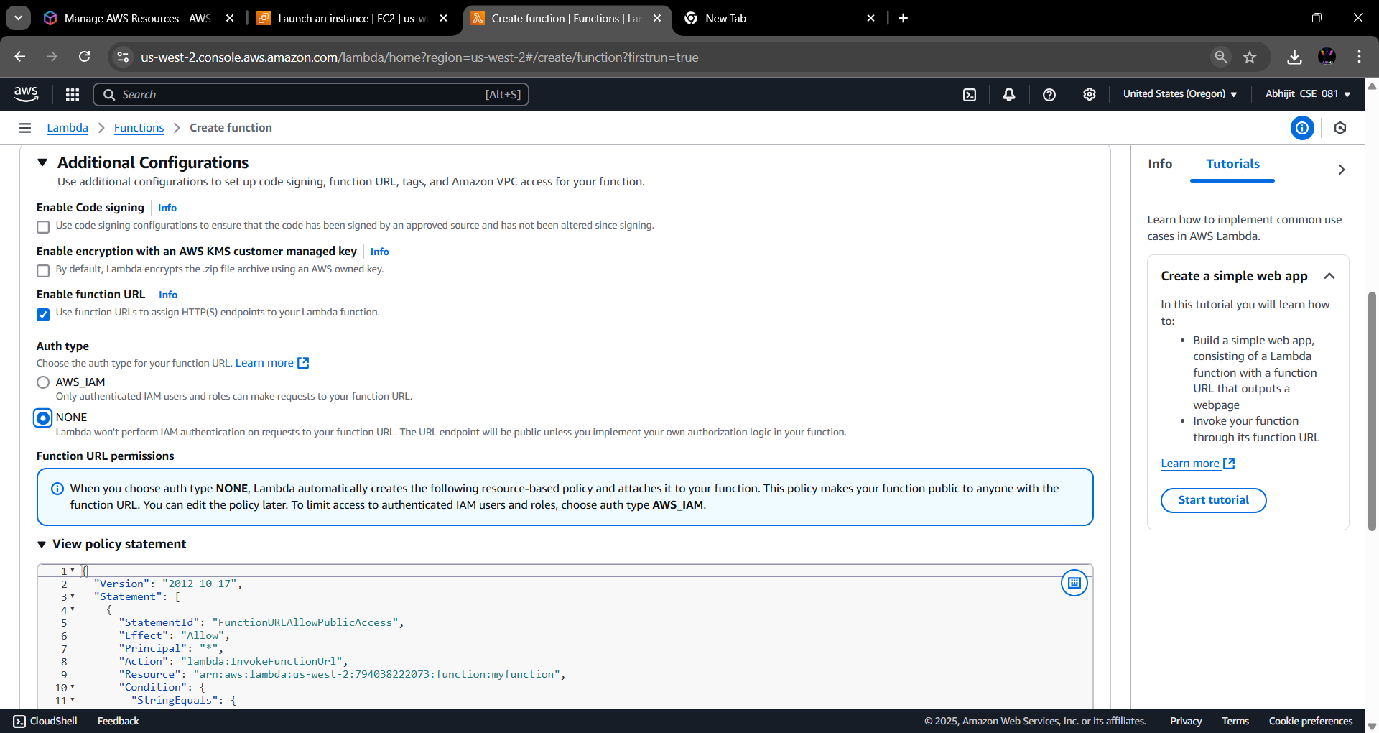

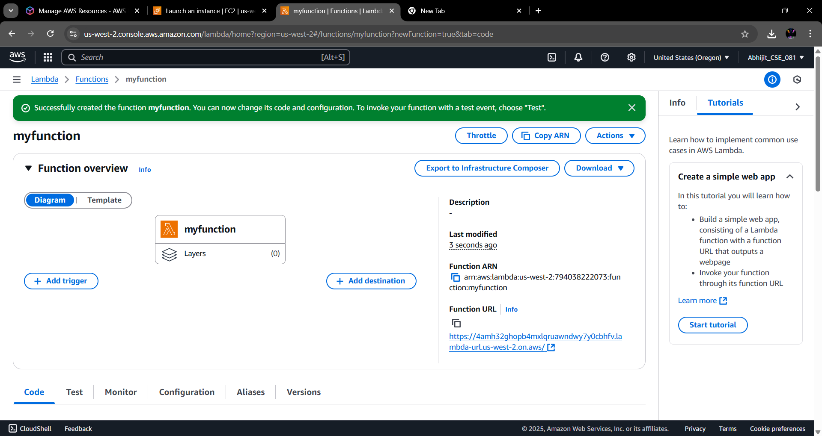
Step 5: The function has been created. Now copy the function URL and paste it on a new tab.

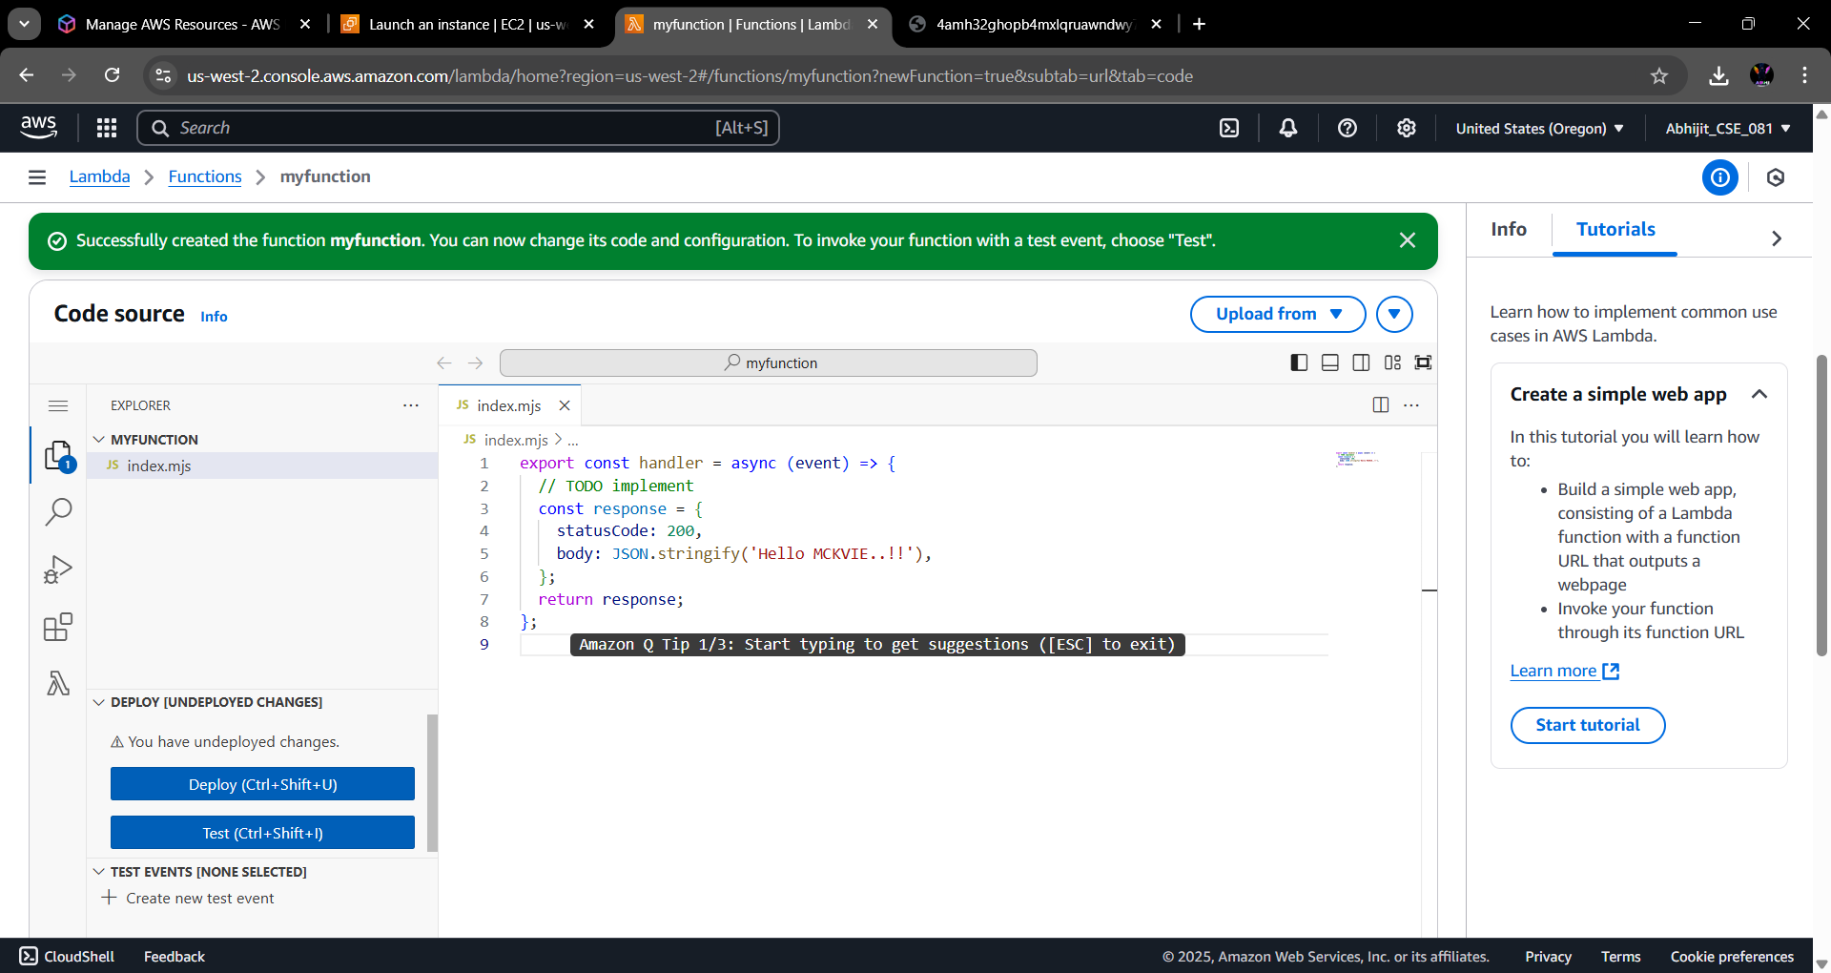
Step 3: Click on the created function and go to the code section of it. There we modify some code and deployed it. open the function URL in a tab.

